Hochschule für Angewandte Wissenschaften Hamburg
Hamburg University of Applied Sciences

Fakultät Technik und Informatik
Studiendepartment Informations- und Elektrotechnik

Laboratory "Operating Systems"
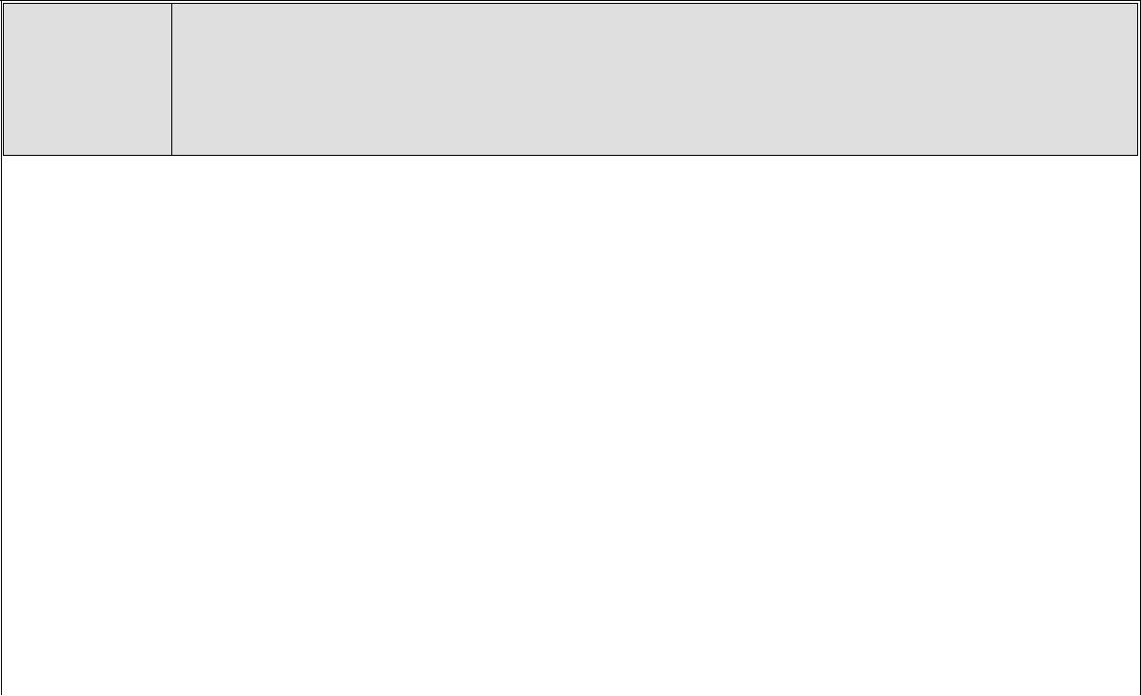
1 Operating Systems Lab-1

(Threads)

Semester / Group

IE-6

Date 28.04.2016

Professor

Ulrich

Sauvagerd

Record editor
Hasan Hasanli

Participant
Mohammed Abu Barza

Approvals

Attachment A.

Attachment B.
W₈⁰ | 1
W₈¹ | 1/sqrt(2) - j/sqrt(2)
W₈² | -j
W₈³ | -1/sqrt(2) - j/sqrt(2)
W₄⁰ | 1
W₄¹ | -j
W₂⁰ | 1

Handwritten calculations are:
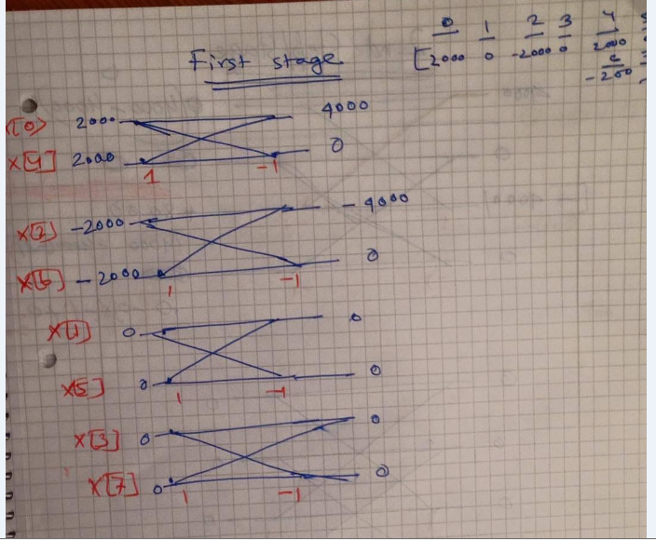
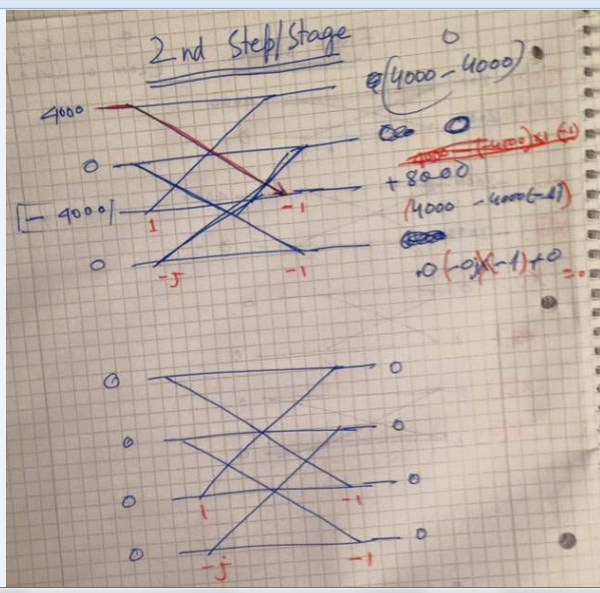
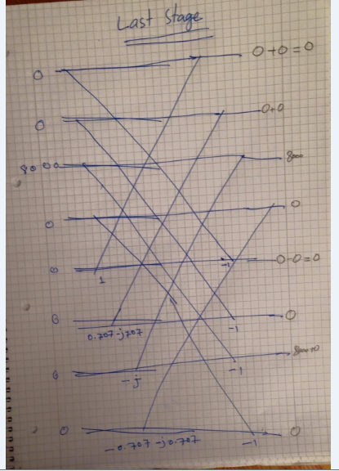
Matlab result of same calculation
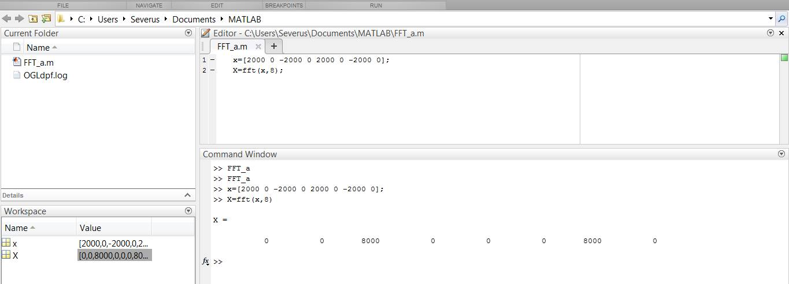

Attachment C.
clear all;
fs=8000;
t=0:1/fs:0.1; %time vector
x = 8192*cos(2*pi*6*(0:7)/8) +j* 8192*sin(2*pi*6*(0:7)/8);
NFFT = 2^nextpow2(length(t)); %Now we calculate the FFT. As FFT-routines only work with vectors whos length are a power of 2, we calculate the FFT length and then do the FFT.
X=fft(x,NFFT);
f = (0:(NFFT-1)) * fs/NFFT; %The frequency resolution of the FFT is fs/NFFT. As the length of the FFT vector is NFFT and the frequency starts at zero (DC), frequency vector is
plot(f,abs(X));
%SEE plot is not Symetrical

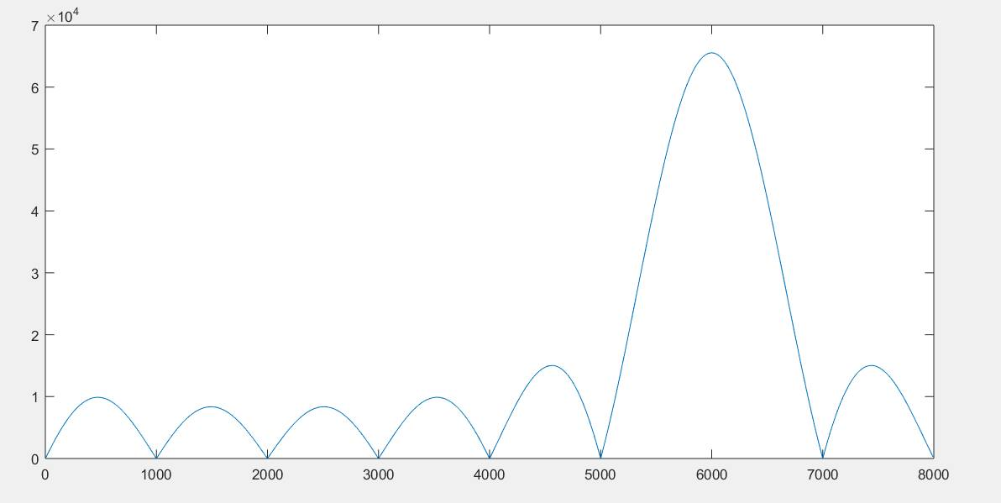

To determine maximum number of samples N_{FFT} at which FFT analyzer still works in real time we started to test it at N_{FFT} = 8:
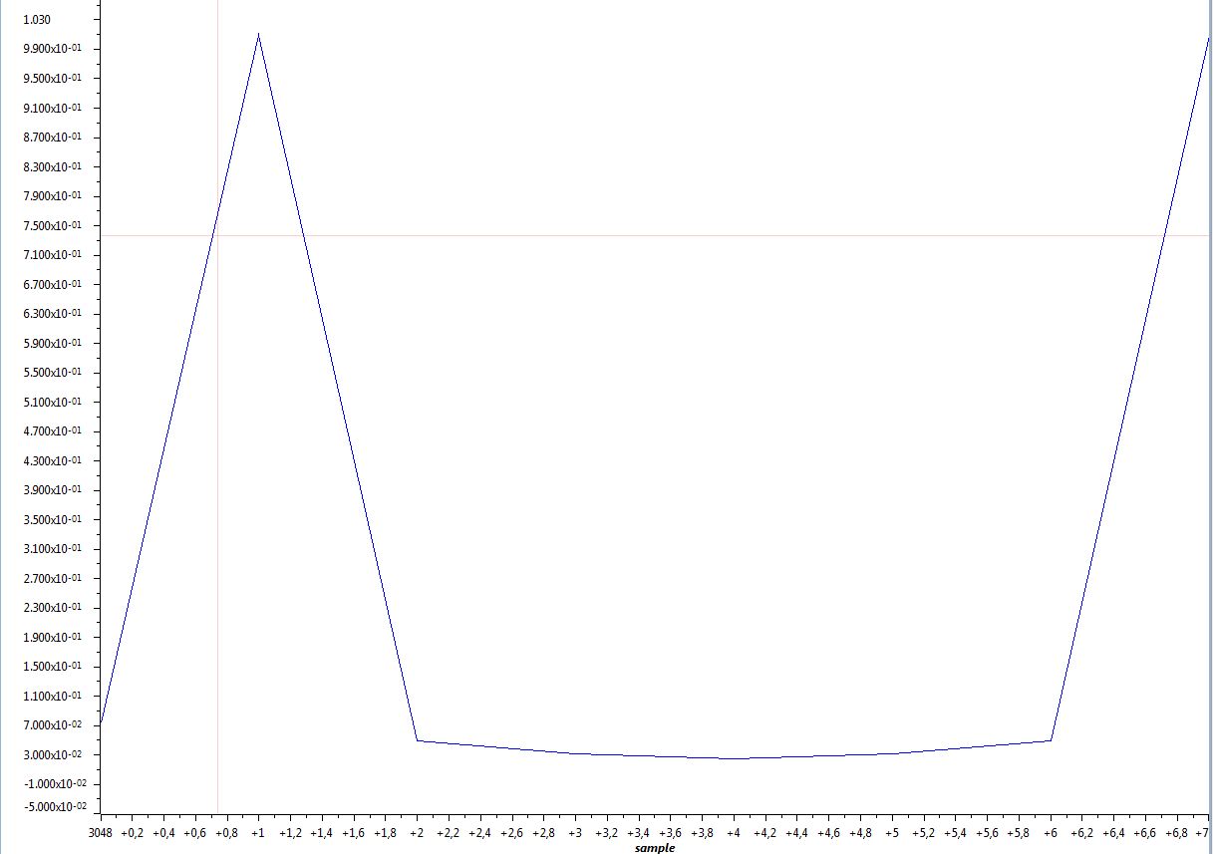
Fig. – Sine wave. N_{FFT} = 8
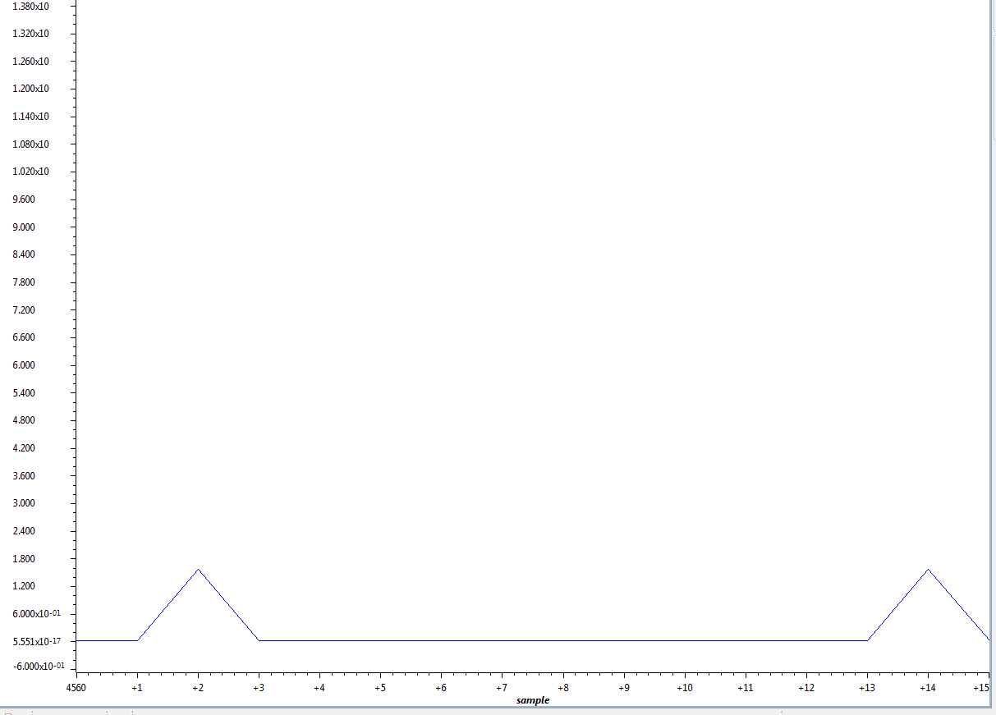
Fig. – Sine wave. N_{FFT} = 16
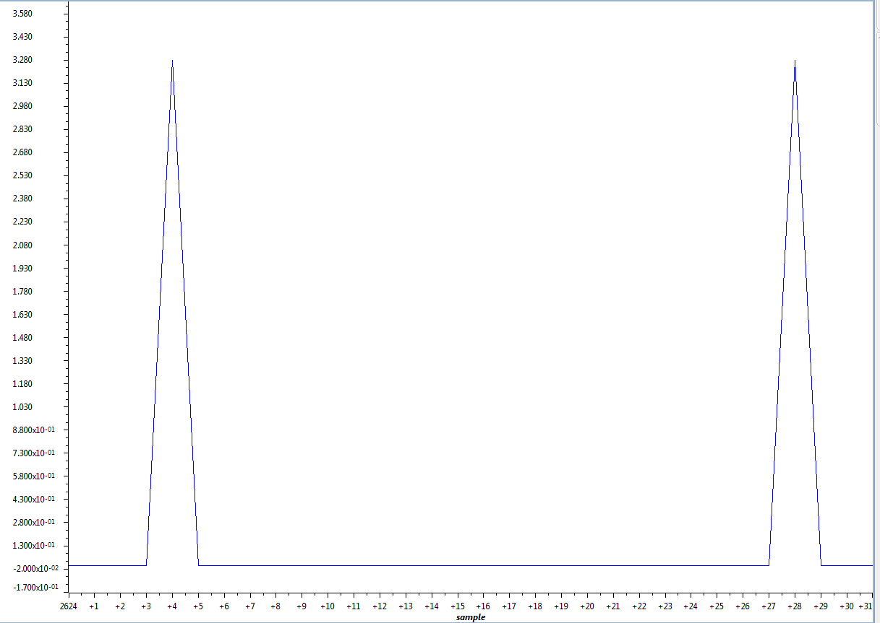
Fig. – Sine wave. N_{FFT} = 32
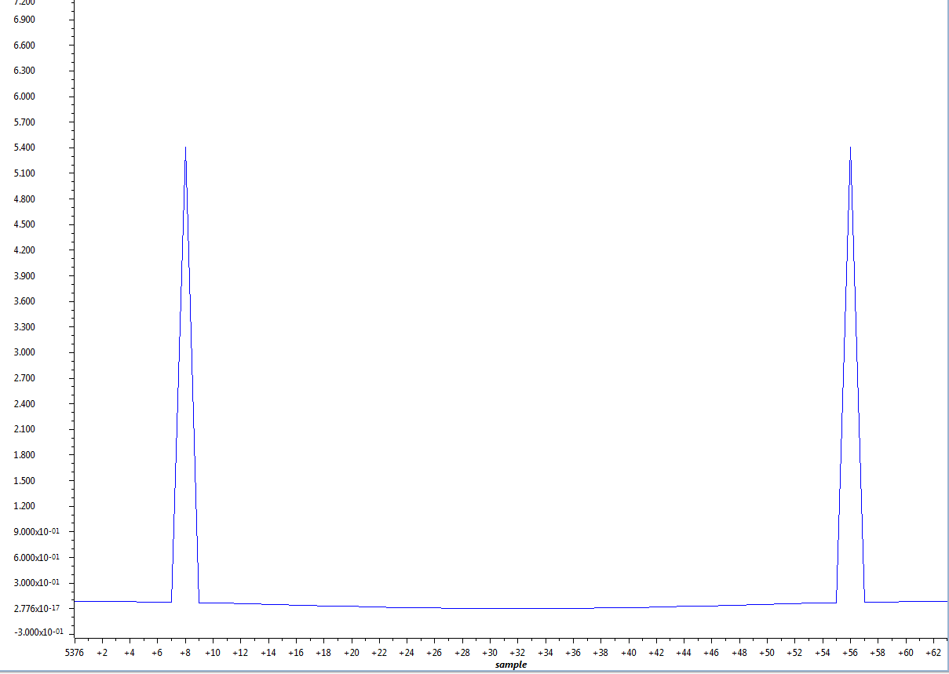
Fig. – Sine wave. N_{FFT} = 64

At N_{FFT} = 128 we already can’t see result of FFT on CCS graph. So maximum value of N_{FFT} = 64.
Attachment D.
Using CCS “graph display” in Composer we observed results of FFT.
First we monitor result of sine wave signal from signal generator with 1V amplitude and 1, 2 and 3kHz frequencies.
Fig. – Sine wave signal. 1kHz
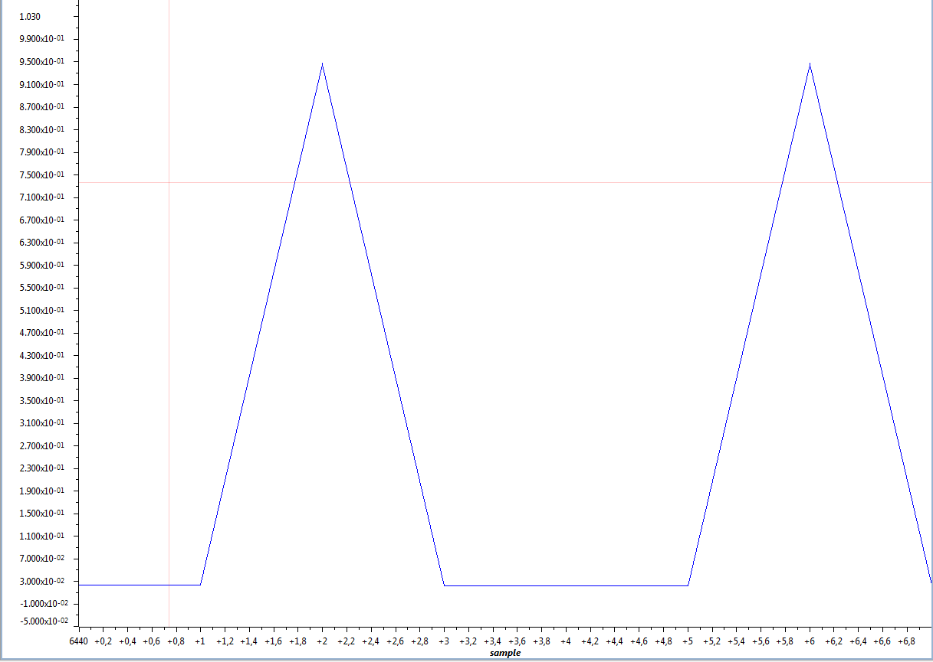
Fig. – Sine wave signal. 2kHz
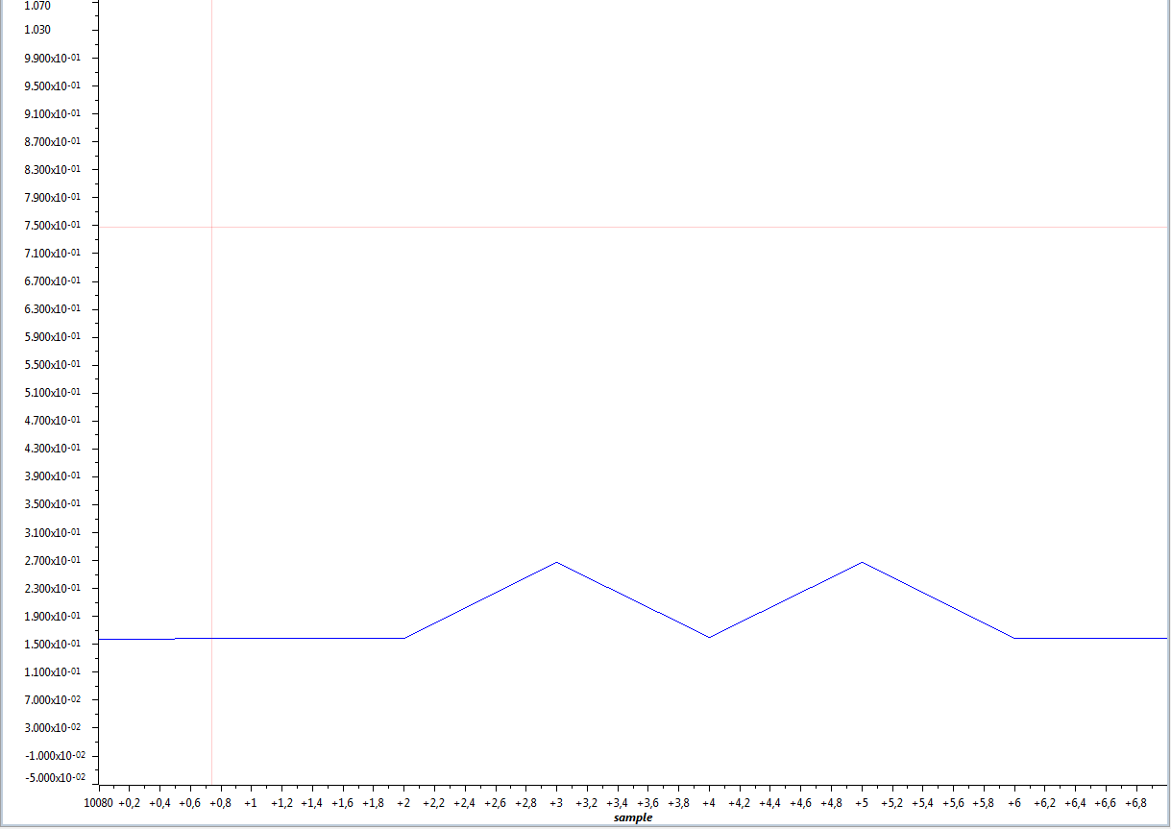
Fig. – Sine wave signal #1. 3kHz
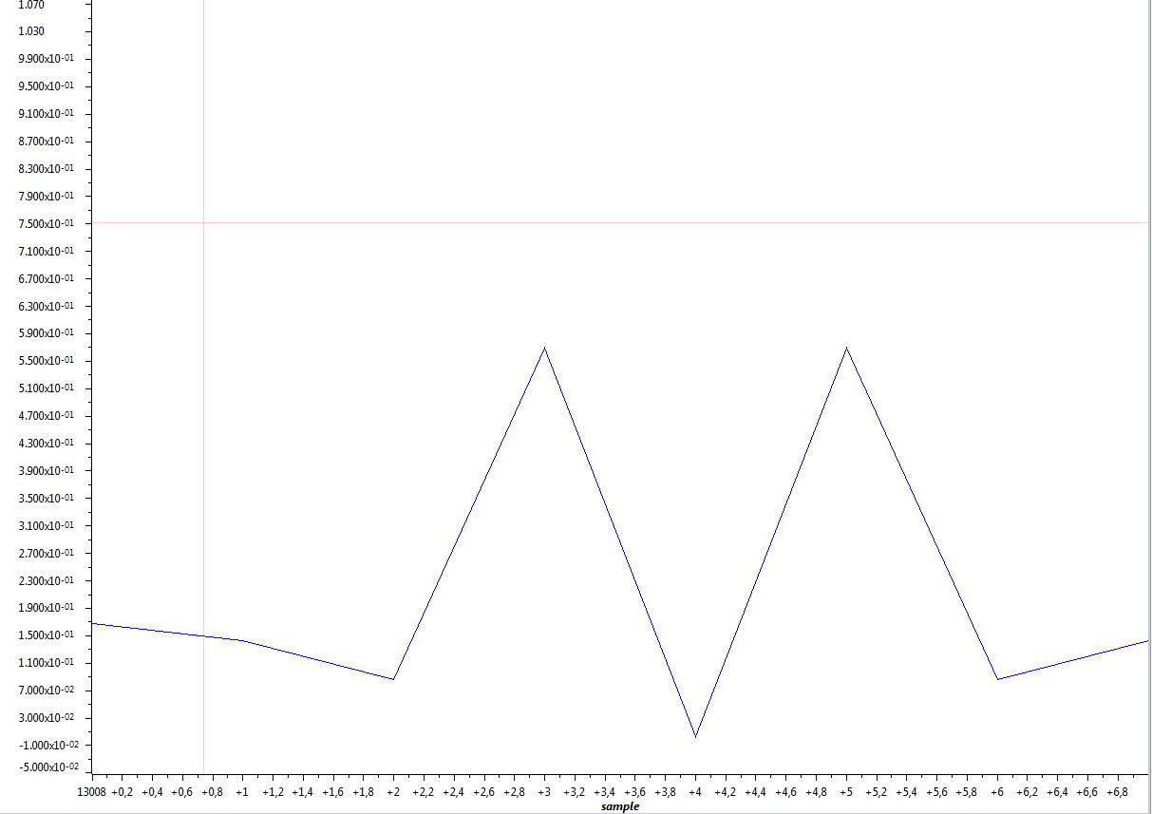
Fig. – Sine wave signal #1. 3kHz

Then we monitor result of square wave signal from signal generator with 1V amplitude and 1, 2 and 3kHz frequencies.
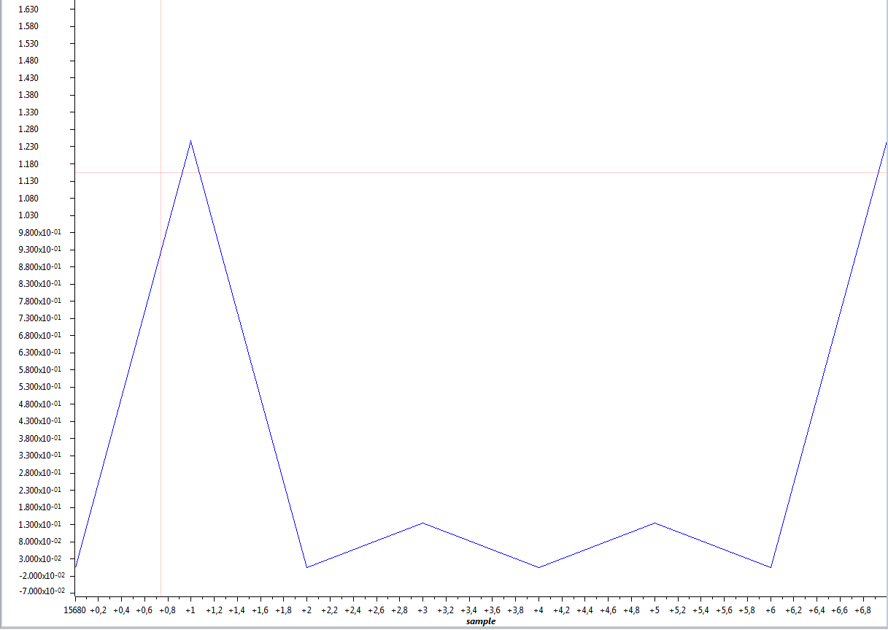
Fig. – Square wave signal. 1kHz
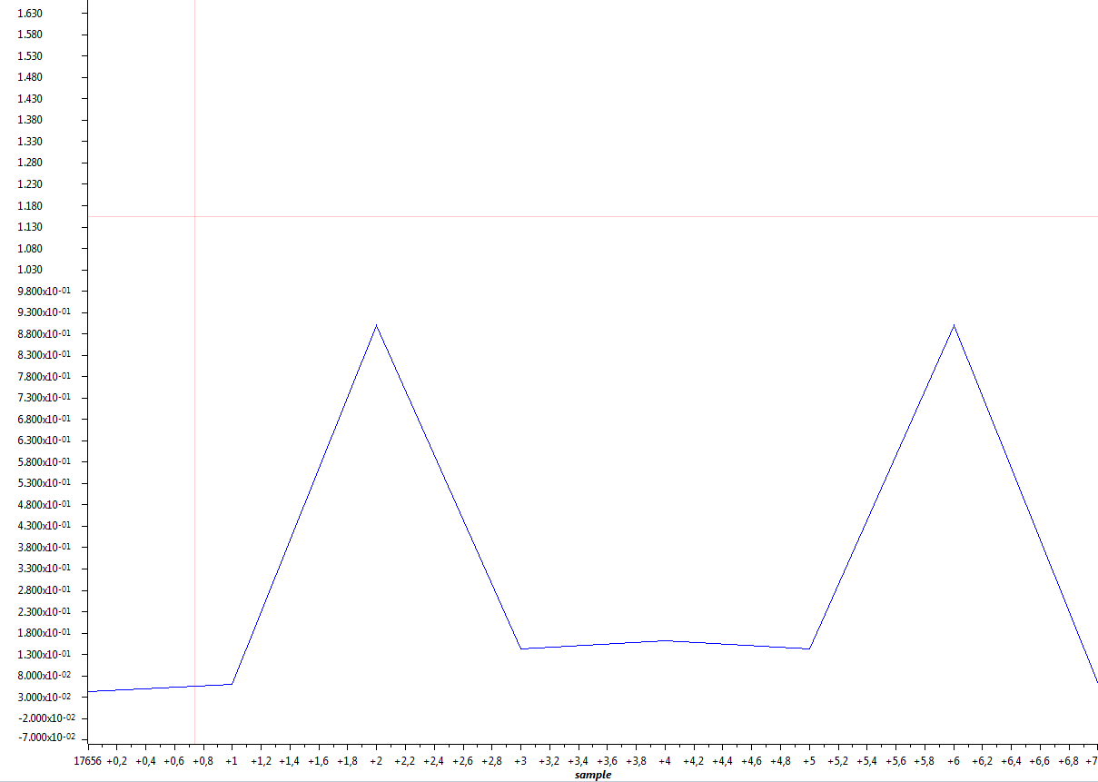
Fig. – Square wave signal. 2kHz
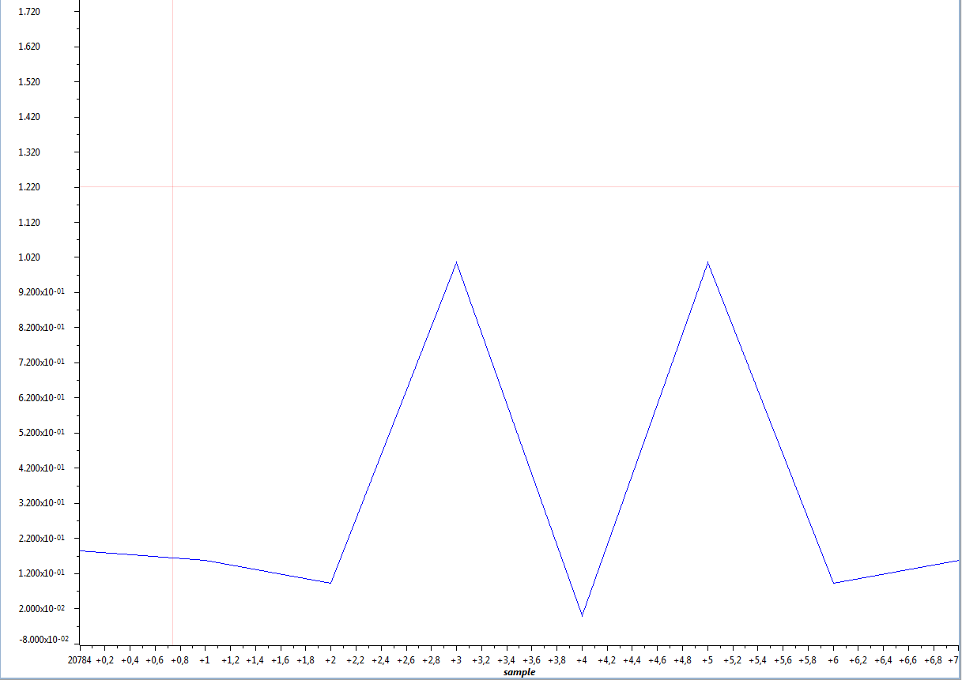
Fig. – Square wave signal. 3kHz

Attachment E.
FFT_LAB.c analyzer:
/*****************************************************
FFT_LAB_Analyser_Radix2_starter_version_NFFT_8.c

US 29-Feb-2011

This is the starter version for Lab 2 IE6 SP.

Description:
============
This program demonstrates the FFT TI CCS.
The routine FFT is called in main() ONCE.

An important requirement for cfftr2_dit.sa is CORRECT data alignment..
The pragmas used below make sure that data are aligned correctly
in memory.

*****************************************************/

//#define SIM

#include <stdio.h>
#include <stdlib.h>
#include <math.h>

#include "c6713dskinit.h" //codec-DSK support file
#include "dsk6713_aic23.h"
#include "dsk6713.h"

Uint32 fs=DSK6713_AIC23_FREQ_8KHZ; //set sampling rate

//-------------------------------------------------------------------------

#define N_FFT 8
#define LEFT 1
#define RIGHT 0
#define BUFLEN 1000
float FFT_buf[2*N_FFT];
float w[N_FFT];
#pragma DATA_ALIGN(w, 2*sizeof(float)) //align w on boundary
#pragma DATA_ALIGN(FFT_buf, 2*sizeof(float)) //align input FFT_buf on boundary
//------------ prototypes -------------------------------------------------------------
short bitrev(short in, short N_FFT_stages);
void cfftr2_dit( float *x, const float *w, short N);

//Global variables:
short i;
short j;
short indx;
double PI;
short index[N_FFT];
short sample_count = 0;
float out_buf[N_FFT];
float float_scale = 0;

#ifdef SIM
// provide for simulator
interrupt void intser_McBSP1()
{

}
#else
extern MCBSP_Handle DSK6713_AIC23_DATAHANDLE;
static Uint32 CODECEventId;

union {
Uint32 both;
short channel[2];
} AIC23_data;

interrupt void intser_McBSP1()
{
AIC23_data.both = MCBSP_read(DSK6713_AIC23_DATAHANDLE) / 32767.0f; // input data
FFT_buf[2 * sample_count] = (float)AIC23_data.channel[RIGHT]; // gets input from signal generator. To 0 and even positions we write real part
FFT_buf[2 * sample_count + 1] = 0; // gets input from signal generator. To odd positions we write imag part

AIC23_data.channel[RIGHT] = (short)out_buf[sample_count]<<15; // result of multiplication of 2 floats is float, but first 15 values of it are 0s
AIC23_data.channel[LEFT] = 0;

if (sample_count == 0) {
AIC23_data.channel[LEFT] = 32767;
}
else {
AIC23_data.channel[LEFT] = 0;
}

sample_count++;
MCBSP_write(DSK6713_AIC23_DATAHANDLE, AIC23_data.both); // output 32 bit LEFT and RIGHT

return;
}
#endif

void main()
{
// calculate PI
PI = 4 * atan(1);
float_scale = (32768.*32768.* N_FFT);

#ifndef SIM
IRQ_globalDisable(); //disable interrupts
DSK6713_init(); // call BSL to init DSK-EMIF,PLL
#endif
// generate bit-reversed indicees, log10(N_FFT)/log10(2) is number of stages
for (i=0;i<N_FFT;i++)
index[i] = bitrev(i, log10(N_FFT)/log10(2));

// generate signel with 8 sampels, MUST BE in normal order !!
for (i=0;i<N_FFT;i++) {
FFT_buf[2*i] = (float) ( 8192 * cos(2*PI*2*i/N_FFT) );//+
FFT_buf[2*i+1] = 0;
}

// generate twiddle factors, MUST BE bit-reversed, sin() must be POSITIVE !!
j=0;
for (i=0;i<N_FFT/2;i++) {
w[index[j] ] = (float) +cos(2*PI*i/N_FFT);
w[index[j]+1] = (float) +sin(2*PI*i/N_FFT); // +sin() is CORRECT !!
j++;
}

// calculate FFT via assembler routine
/* cfftr2_dit( FFT_buf, w, N_FFT);
j=0;
for (i=0;i<2*N_FFT;i+=2)
{
indx = 2*index[j];
out_buf[j]= ( (FFT_buf[indx] * FFT_buf[indx] +
FFT_buf[indx+1] * FFT_buf[indx+1])) / float_scale;
j++;
}
*/
#ifndef SIM
// handle(pointer) to codec
hAIC23_handle=DSK6713_AIC23_openCodec(0, &config);
DSK6713_AIC23_setFreq(hAIC23_handle, fs); //set sample rate

//interface 32 bits to AIC23
MCBSP_config(DSK6713_AIC23_DATAHANDLE,&AIC23CfgData);

//start data channel
MCBSP_start(DSK6713_AIC23_DATAHANDLE, MCBSP_XMIT_START | MCBSP_RCV_START |
MCBSP_SRGR_START | MCBSP_SRGR_FRAMESYNC, 220);

CODECEventId= MCBSP_getXmtEventId(DSK6713_AIC23_DATAHANDLE);//McBSP1 Xmit
IRQ_map(CODECEventId, 5); //map McBSP1 Xmit to INT5
IRQ_reset(CODECEventId); //reset codec INT5
IRQ_globalEnable(); //globally enable interrupts
IRQ_nmiEnable(); //enable NMI interrupt
IRQ_enable(CODECEventId); //enable CODEC eventXmit INT5
IRQ_set(CODECEventId); //manually start the first interrupt
#endif

//--------------------------------------------------------------------------
// put your code for buffer handling of spectrum analyser into while(1)-loop
while(1)
{
if (sample_count >= N_FFT){ // checks if buffer is already full
j=0;
// IRQ_globalDisable(CODECEventId); //disable interrupts
cfftr2_dit( FFT_buf, w, N_FFT); //calculate fft
for (i=0;i<2*N_FFT;i+=2)
{
indx = 2*index[j];
out_buf[j]= ( (FFT_buf[indx] * FFT_buf[indx] +
FFT_buf[indx+1] * FFT_buf[indx+1])) / float_scale;
j++;
}
sample_count = 0; // reset number of samples which were already read from ADC
// IRQ_globalEnable(CODECEventId); //enable interrupts
}

} // end of while(1) loop ...
//--------------------------------------------------------------

} // end of main()

Using CCS “graph display” in Composer we observed typical FFT plots of sine wave with 1V amplitude and 0.5, 1, 2 and 3kHz frequencies.
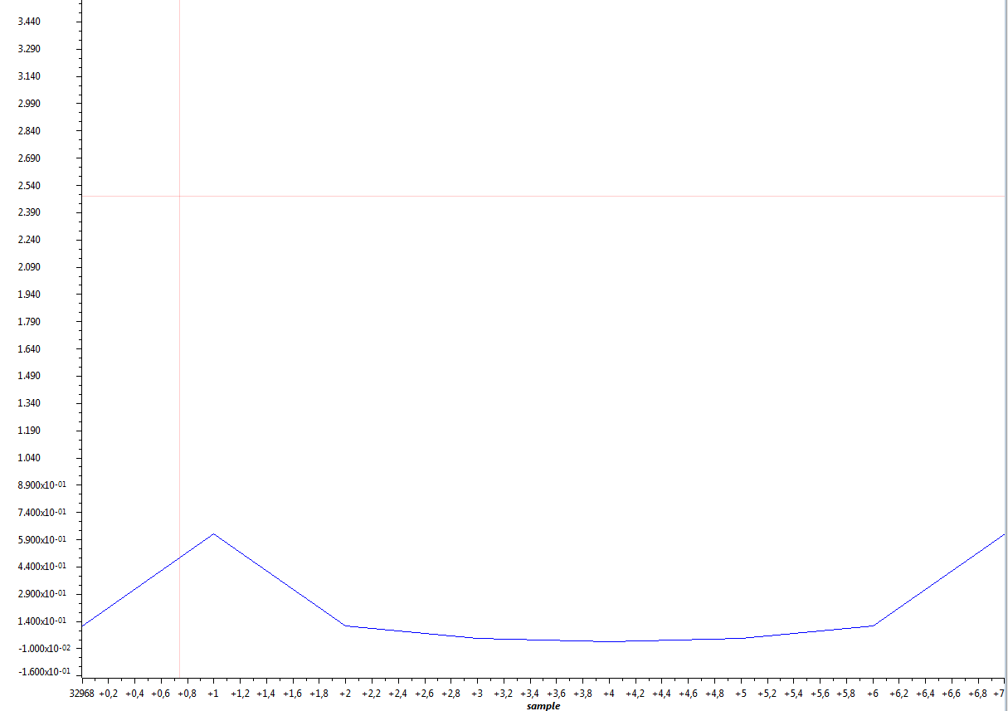
Fig. – Square wave signal. 0.5kHz
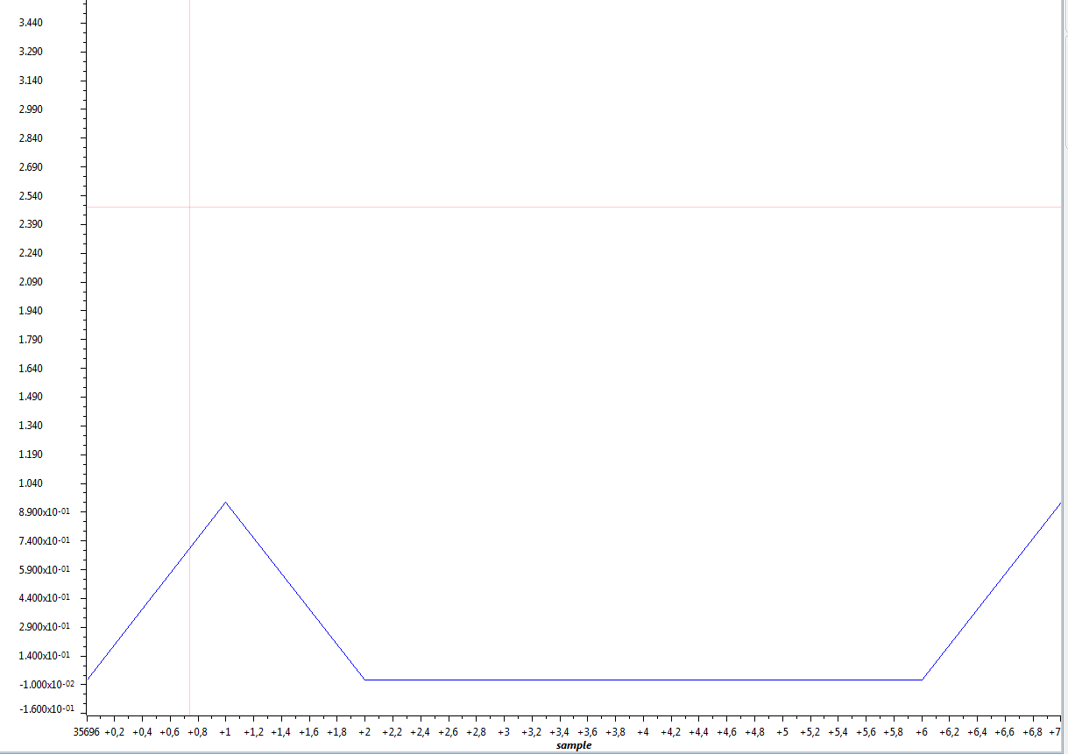
Fig. – Square wave signal. 1kHz
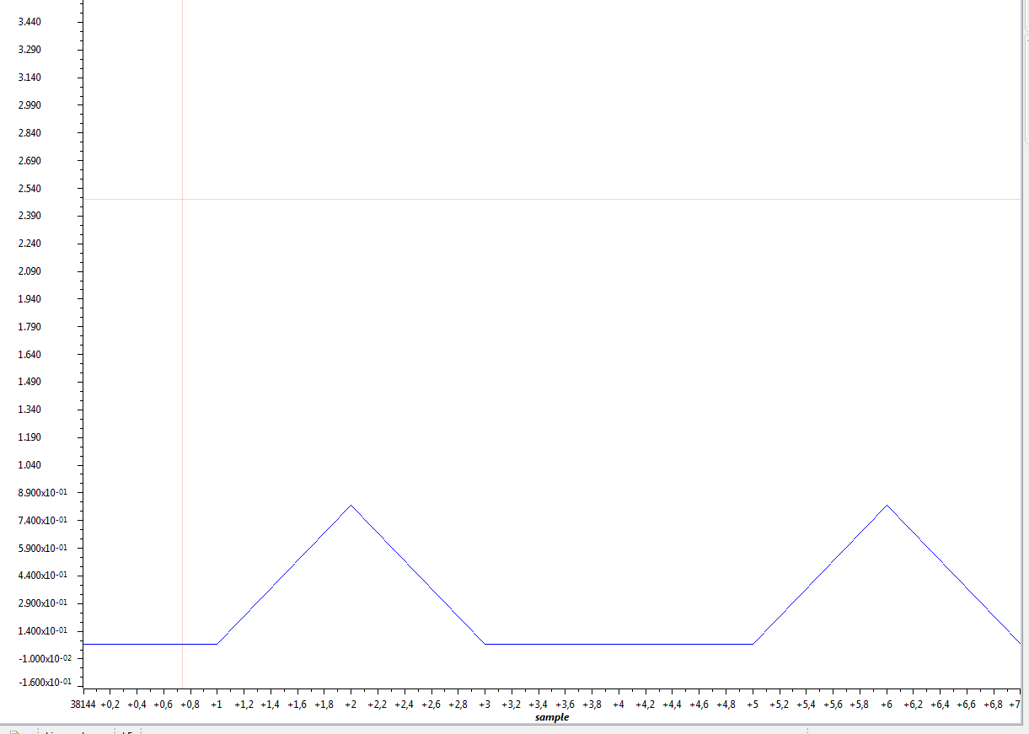
Fig. – Square wave signal. 2kHz
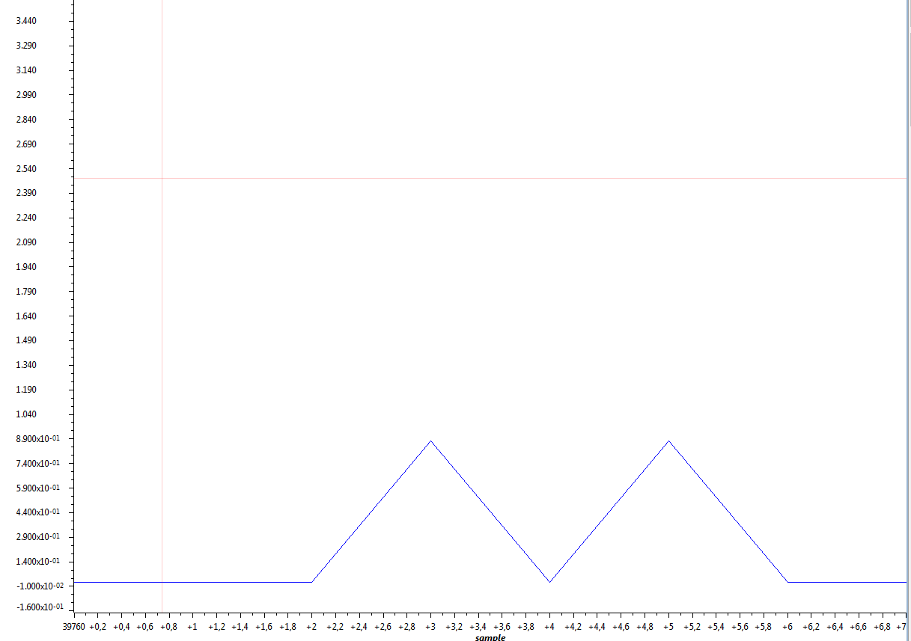
Fig. – Square wave signal. 3kHz
Conclusion.
From graphs above we can observe that changing of frequency and shape of input signal directly affects results of FFT which we monitor on CCC “graph display”.
Number of samples N_{FFT} also affects result of FFT. To store and calculate FFT values we were usibg just one buffer. That caused that maximum number of N_{FFT} is just 64 samples. By using two stacks : one for storing values and one for calculating we could increase efficiency of program and increase maximu value of N_{FFT .}

